**Introduction:**

The idea of this application is to connect people with each other for the car pool.

The users will have the option to register themselves in the application as a driver

or as a passenger.

**Scope:**

**We started this project a month back with target of completing it within 2 weeks which we achieved successfully while the last week was for testing the code.**

**Pictures:**

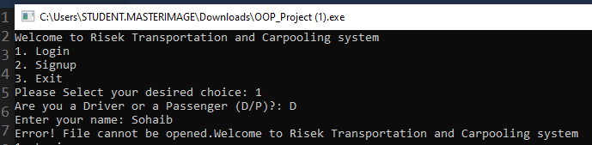

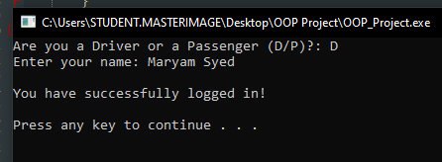

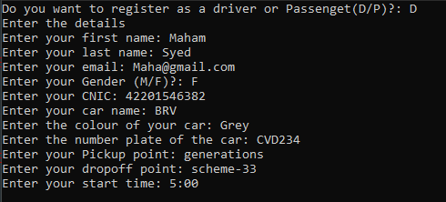

UML:



